CelcomDigi Daily Roaming Pass
1. Launch Details
Key Summary USP | Daily Roaming Pass enables postpaid subscribers to access mobile internet while travelling overseas with automatic activation and controlled daily charges.
Channels | - N/A - Daily Roaming Pass is auto activated upon detection of 1MB Roaming Data usage. This pass cannot be subscribed manually.

2. Product Details
Offering Details | Daily Roaming Pass  Price RM39  Quota Allocation - 1GB - 2GB for Singapore, Indonesia, Thailand (effective 15th July 2025)  Validity 24 hours  Eligible Country 95 countries. The list of the supported countries can be found here Note: All the countries that support Multi-Day Pass also support Daily Roaming at RM39 per day  Eligible Plan All postpaid plan  Effective December 19, 2023: Prepaid subscribers are not allowed to use roaming services unless a roaming pass is purchased.  Postpaid  Celcom Digi  1GB – 123 countries (throttled at 256kpbs after 1GB) 1GB – 128 countries (throttled at 256kpbs after 1GB)  Prepaid  Not eligible  Tier Charging Block Daily Roaming Pass Charging Construct  Tier 1 1st 100kb RM0  Tier 2 100kb – 300kb RM7.80  300kb – 500kb RM7.80  500kb – 700kb RM7.80  700kb – 900kb RM7.80  Tier 3 900kb – 1024kb RM7.80 (RM39 will be triggered at this tier)

3. Eligibility and Criteria
Eligibility & Criteria | - All Postpaid plan subscribers

4. Customer Journey (current journey / campaign only)
Customer Journey | Daily Roaming Pass is auto activated upon detection of 1MB Roaming Data usage.  - To have Daily Roaming Pass automatically activated, customer need to turn on your data roaming settings on your device.  - After the 1GB or 2GB data allowance has been fully utilized, customer will receive 100% usage utilization and data speed will be throttled to up to 256Kbps.  - However, once the 50MB allowance is fully used, data will be blocked.

5. Customer Communications (Active)
Active Comms | Refer to the table below for exclusion areas of roaming service  Australia Australia’s 3G shutdown: To ensure uninterrupted roaming services, advice subscribers to check device compatibility: How to Check Device IMEI Eligibility Step 1: ​ Dial *#06# on your mobile phone. Alternatively: - iPhone/IOS: Go to Settings > General > About​ - Android: Go to Settings > About Phone > Status​ Step 2:​ - Go to CelcomDigi Website (Roaming Page), select ‘Australia’ for roaming country and subscribers will be directed to https://amta.org.au/3g-closure-old/check-my-device/ to check the device eligibility. - Go to https://amta.org.au/3g-closure-old/check-my-device/ and enter the 15-digit IMEI number and click ‘Check​’. Upon search, customer will see the below depending on the results: Eligible device 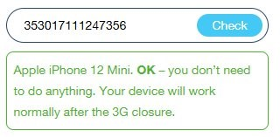 Non-eligible device 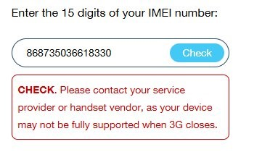  Thailand - Roaming services are not available in Pattani, Yala (e.g. Betong), Narathiwat, Chana District, Nathawi District, Thepha District and Saba Yoi District. - Due to the ongoing situation along the Thailand–Cambodia border, roaming services are temporarily unavailable in areas close to the border. This disruption is localized and limited to approximately 10 KILOMETRES from the border towards inland (Thailand) areas highlighted in red. 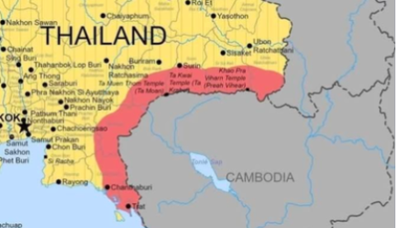  India - Roaming services are not available in Jammu, Kashmir, Assam, and Northeast regions due to restrictions set by the Government of India.  Myanmar - Internet roaming services are unavailable, but voice calls (direct dial) and SMS are available.  USA - AT&T’s 3G network was phased out on 22nd February 2022, resulting in potential intermittent voice interruptions in some areas. Please use WhatsApp calls as an alternative until further notice. - 4G networks are available for Internet browsing.  United Kingdom & Japan - EE’s and Softbank's 3G have committed to closed on 12th March 2024/15th April 2024. - 2G, 4G/LTE & 5G networks are available for Internet browsing.  China - Devices must support TD-SCDMA frequency mode while roaming on China Mobile’s 3G network.  Japan, South Korea, Singapore - 3G-enabled mobile devices are required to use roaming services.  Russia - Starting 6 October 2025, Russian mobile operators will block mobile data and SMS services for 24 hours for all roaming users upon first network registration. - The block is automatic and lifted after 24 hours. - If the SIM remains inactive for 3 days, the 24-hour block will apply again. - Voice calls are not affected and remain fully available.
FAQs | https://help.celcomdigi.com/en/support/solutions/articles/70000657865-daily-roaming-pass
Website | https://www.celcomdigi.com/roaming/multi-day-pass

6. Internal Information
Visuals | NA
Internal FAQ | NA

7. Reference Guide (Agent Guide, Scenario Handling and Other References)
Reference Guide

8. Historical Communications (no longer active but retained for reference only)
Inactive Comms | NA
Inactive Customer Journey | NA

